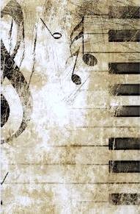

**Please join  
the NHHS Music Department   
& the North Hunterdon Music Association  
for our annual and newly renamed  
New Music Student Welcome Party**

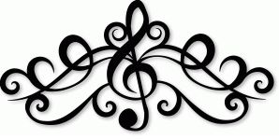

**Parents and students ~**

**We invite you to a wonderful evening of virtual music performances, parent and faculty greetings and student introductions in their own words.  
You will be treated to performances by the Freshman Women’s Ensemble   
and Golden Lions Marching Band.**

**Come to learn more about the music department and the NHMA  
When: Wednesday, November 18, 2020 at 7PM**

**Where: From your own home using the following zoom link:**

[**https://us02web.zoom.us/j/82116139837?pwd=SjU1N0VMYVZianhTaWJnTllsV0R0dz09**](https://us02web.zoom.us/j/82116139837?pwd=SjU1N0VMYVZianhTaWJnTllsV0R0dz09)