Name:_______________________________ Date:__________________ Mods:_____________

Map of Asia

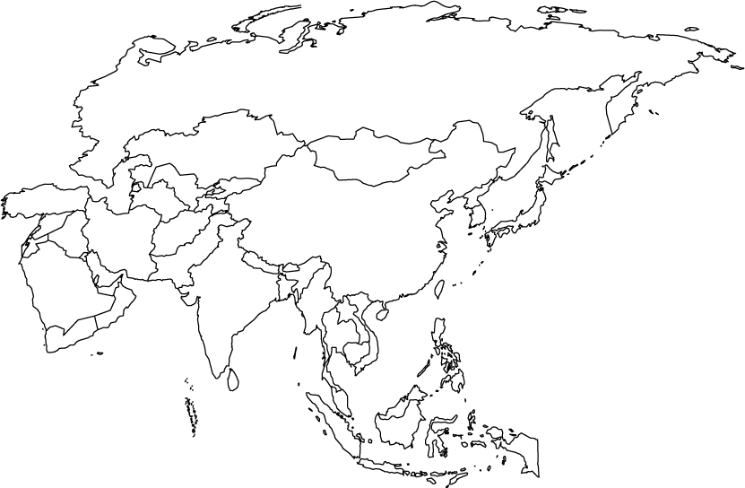
Directions: Identify the locations of the following places by writing the correct letter next to the number.

__________ 1. Japan
__________ 2. India
__________ 3. China
__________ 4. Korea
__________ 5. Mongolia
__________ 6. Indonesia
__________ 7. Malaysia
__________ 8. Philippines
19.1- Europeans Explore the East
Directions: Answer each of the following in complete sentences.

- Why did Europeans want to explore foreign lands by the 1400s?

- What was the profitable business that Asia could provide?

- Who controlled trade routes? Explain the process.

- How did the Crusades influence the motives of European traders?

- What technological improvements allowed Europeans to explore? Describe how they work.

- Which Portuguese leader established Portugal as the dominant exploration country? Why did he so adamantly support exploration?

- Where did Bartolomeu Dias and Vasco da Gama each explore respectively?

- Why did tensions increase between Spain and Portugal during the late 1400s? How did they resolve the tension?

- What did Portugal do to Muslim-Italian trade relations? Why did most of Europe support this?

- How did the Netherlands (Dutch) become such an important country in world trade?
19.2- China Limits European Contacts

Directions: Write True or False in the space provided. If False, correct the false statement in the blank space below the statement.

__________ 1. In general, Ming leaders supported the arrival of European traders into China.

__________ 2. While his father focused on domestic issues, Yonglo was very curious about the rest of the world and sponsored multiple voyages to show the world the power of the Ming dynasty.

__________ 3. Following the voyages of Zheng He, China’s position in world affairs was one of active involvement.

__________ 4. As trade flourished along the Chinese coast, China became highly industrialized.

__________ 5. The Qing Dynasty, a group of non-Chinese invaders, ended the Ming dynasty and slowly gained the respect of its subjects.

__________ 6. The Qing Dynasty and its Manchu leaders ended Chinese isolation.

__________ 7. The Chinese accepted the French as trading partners because they followed Chinese rules, paid tribute through gifts, and performed rituals of respect such as the “kowtow” ritual.

__________ 8. Unlike the Dutch, the British struggled to maintain relations because they did not like China’s trade restrictions and diplomats refused to perform the kowtow.

__________ 9. In general, the 1600 and 1700s were a period of war and poverty in China.

__________ 10. A population boom in China led to the practice of favoring daughters over sons.

19.3- Japan Returns to Isolation

- Daimyo  - Oda Nonbunaga  - Toyotomi Hideyoshi  - Tokugawa Ieyasu  - Matsuo Basho | F. Kabuki  G. Francis Xavier  H. Edo  I. Tokugawa Shogunate  J. Portugal

__________1. Controlled most of Japan and eventually invaded Korea, strong ally with Tokugawa Ieyasu

__________2. A great haiku poet who exemplified the enrichment of culture under the Tokugawa Shogunate

__________3. A Jesuit who led the first mission to Japan, led to over 300,000 Japanese conversions to Christianity.

__________4. Brought muskets, cannons, clocks, eyeglasses, and tobacco to Japan.

__________5. Powerful government set up by Ieyasu that would rule until the 19th century

__________6. Emperor who wanted to “Rule the empire by force” and ultimately committed suicide.

__________7. Became the capital city, would eventually be known as Tokyo

__________8. Samurai warrior-chieftans who seized control of Japanese land and set up feudalism in Japan by offering protection for loyalty.

__________9. A type of traditional Japanese theater known for extravagant makeup and men playing all roles

__________10. Leader who completed the unification of Japan and set up the shogunate that would hold power until 1867

