Answers to the Reteaching 13.4
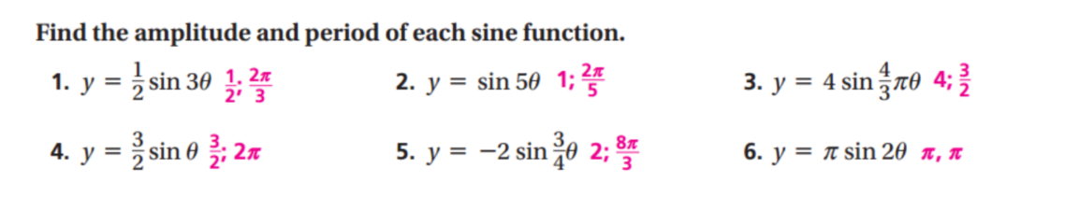
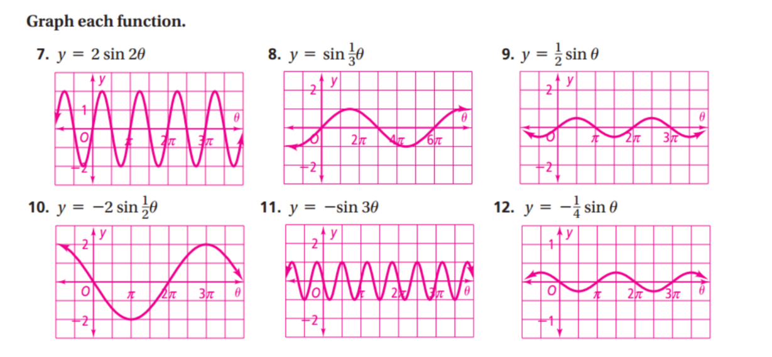
Answers to the Reteaching 13.5
