Magnetism Chapter Questions

- Both Electric and Magnetic Forces will cause objects to repel and attract each other. What is a difference in the origin of these forces?

- A Magnet has a north and a south pole. If you cut the magnet in half, describe what happens to each end of the two pieces. How many times can you cut the magnet in half and get this same result?

- Can you find a magnet with just a north pole? Why or why not?

- Electric Field lines start on a positive charge and end on a negative charge. Describe the behavior of a Magnetic Field line.

- What Field circles a current carrying wire?

- When drawing a Magnetic Field line on a sheet of paper, what is the symbol for the field line coming out of the page towards you? What is the symbol for a Magnetic Field line entering the page?

- A stationary positive charge is placed in a Magnetic Field. What force does the charge feel from the Field? What force does a moving charge feel when it enters a Magnetic Field and its velocity is perpendicular to the direction of the field?

- Compare/contrast the Magnetic Force that a moving electron experiences when it enters perpendicular to a Magnetic Field to the force that a moving proton feels. Are the magnitudes of their acceleration the same? Explain.

- A moving electron enters a Magnetic Field and its velocity is parallel to the direction of the field lines. What is the Magnetic Force on the electron?

- Current flows through a wire that is in a Magnetic Field. What happens to the wire?

- Two current carrying wires are parallel. When current flows in the same direction in both wires, what happens to the wires? If the current flows are opposite, what happens to the wires?

- What is the purpose of a Mass Spectrometer?

Chapter Problems
Magnetic Fields
Class Work
- Draw the Magnetic Field lines created by the below bar magnet.

- Draw the Magnetic Field lines created by the below two bar magnets

Homework
- Draw the Magnetic Field lines created by the below bar magnets.

- Draw the Magnetic Field lines created by the below two bar magnets.

Origin and Direction of Magnetic Fields
Class Work
- An electric current flows to the right as shown below. Draw the Magnetic Field lines due to this current.

- A magnetic compass as shown below is placed above a current carrying wire. If the current flows into the page, what is the compass orientation? Label the north and south poles of the compass needle.

- A current flowing through a wire generates the below Magnetic Field. What is the direction of the current?

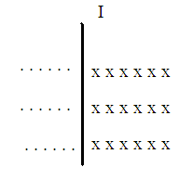

- The below electric current flows out of the page. Draw the Magnetic Field lines, including direction, due to this current.

- In the below diagram, an electric current flows towards the top of the page. Draw the Magnetic Field direction at Point P.

- On the below diagram, indicate the direction of the electric current that would generate the indicated Magnetic Field.
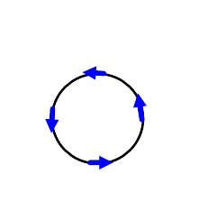
Homework
- An electric current flows to the left as shown below. Draw the Magnetic Field lines due to this current.

- A magnetic compass as shown below is placed below a current carrying wire. If the current flows out of the page, what is the compass orientation? Label the north and south poles of the compass needle.

- A current flowing through a wire generates the below Magnetic Field. What is the direction of the current?

- The below electric current flows into the page. Draw the Magnetic Field lines, including direction, due to this current.

- In the below diagram, an electric current flows towards the bottom of the page. Draw the Magnetic Field direction at Point P.

- On the below diagram, indicate the direction of the electric current that would generate the indicated Magnetic Field.
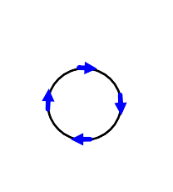
Magnetic Field force on a moving Electric Charge
Class Work
- A proton (e=1.6 x 10⁻¹⁹ C), moving at a speed of 3.0 x 10⁴ m/s enters a Magnetic Field of 0.55 T as shown below. Find the direction and the magnitude of the Magnetic Force on the proton.

- A proton moving at a speed of 45,000 ^{m}/_{s} horizontally to the right enters a uniform magnetic field of 0.15 T which is directed vertically downward. Find the direction and magnitude of the magnetic force on the proton.

- An electron has a horizontal velocity of 6.0 x 10⁵ ^{m}/_{s} towards the east. It travels through a 0.24 T uniform magnetic field which is directed straight down. What is the direction and magnitude of the magnetic force on the electron?

- An electron experiences a maximum upward force of 2.5 x 10⁻¹² N when it is moving at a speed of 2.1 x 10⁶ ^{m}/_{s} towards the north. What is the direction and magnitude of the magnetic field?

Homework
- A proton experiences a maximum downward force of 9.0 x 10⁻¹⁶ N when it travels at a speed of 6.0 x 10⁴ ^{m}/_{s} towards the west. What is the direction and magnitude of the magnetic field?

- An electron (m_{e} = 9.1 x 10⁻³¹ kg) traveling south at a constant speed of 5.0 x 10⁶ ^{m}/_{s} enters a region where the downward component of earth’s magnetic field is 3.5 x 10⁻⁵ T. What is the magnitude and direction of the acceleration of the electron at this instant?

- An alpha particle (q = 3.2 x 10⁻¹⁹ C and m = 6.6 x 10⁻²⁷ kg) travels at a speed of 8.0 x 10⁶ ^{m}/_{s} in the +x direction. A uniform magnetic field with a magnitude of 1.2 T is pointed in the +y direction. Find the magnitude and the direction of the acceleration of the alpha particle at the moment when it is injected into the field.

- An electron moving at a speed of 4.0 x 10⁵ m/s enters a 0.65 T magnetic field from the left as shown below. Find the direction and the magnitude of the Magnetic Force on the electron.

Magnetic Field force on a current carrying wire
Class Work
- A wire carries a current of 25 A in a direction perpendicular to a 0.56 T magnetic field. What is the magnitude of the magnetic force acting on the 1.5 m long wire?

- A 0.90 m long wire, carrying a current of 50.0 A, is oriented at 90˚ to a uniform magnetic field of 0.35 T. What is the magnetic force on the wire?

- A uniform magnetic field exerts a maximum force of 50.0 mN on a 50.0 cm long wire, carrying a current of 45 A. What is the strength of the magnetic field?

- A 0.58 m long wire, carrying a current of 30.0 A, is oriented perpendicularly to a uniform magnetic field. The wire experiences a force of 0.050 N; what is the strength of the magnetic field?

Homework
- A 0.15 N force acts on a 0.40 m wire as a result of it being located in a 0.020 T, perpendicularly oriented, magnetic field. What is the electric current through the wire?

- A 0.38 T, perpendicularly oriented, magnetic field exerts a 1.4 N force on a 30.0 cm long wire. What is the electric current flowing through the wire?

- A wire carries 49 A of current and is located in a 0.85 T, perpendicularly oriented, magnetic field. If the wire experiences a magnetic force of 0.22 N, what is the length of the wire?

- If a wire carrying 23 A of current feels a force of 0.040 N when located perpendicularly to a 0.14 T magnetic field, what is the length of the wire?

Magnetic Field due to a long, straight current carrying wire
Class Work
- What is the magnetic field at a point 20 m away from a wire carrying 50 A of current?

- A straight wire has a current of 150 A flowing north. What is the magnitude and direction of the magnetic field at a point 10.0 m east of the wire?

Homework
- A straight wire carries a current of 30.0 A towards the north. What is the direction and magnitude of the magnetic field at a point 5.0 m to the east of the wire?

- A long straight wire carries a current of 24 A towards the west. What is the direction and magnitude of the magnetic field 3.0 m to the south of the wire?

Magnetic Field force between two current carrying wires
Class Work
- What is the magnitude and direction of the magnetic force between two parallel wires, 30.0 m long and 5.0 cm apart, if each carries a current of 40.0 A in the same direction?

- What is the magnitude and direction of the magnetic force between two parallel wires, 3.5 m long and 20.0 mm apart, if each carries a current of 1.5 A in opposite directions?

Homework
- Two parallel and opposite currents, 2.6 A and 5.7 A, are separated by a distance of 3.0 cm. The length of the wires carrying the currents is 3.4 m. What is the magnitude and direction of the force between the wires?

- Two parallel circuits, carrying currents of 4.3 A and 8.5 A in the same direction, are separated by a distance of 7.0 cm. The length of the wires is 9.6 m. What is the magnitude and direction of the force between the wires?

General Problems

- A thin 2.4 m long aluminum wire, carrying a current to the right, has a mass of 0.15 kg and is suspended above the ground by a magnetic force due to a uniform magnetic field of 1.2 T.

  - On the diagram above, show all the applied forces on the wire.
  - What is the net force on the wire if it is in equilibrium?
  - On the diagram above show the direction of the magnetic field.
  - What is the magnitude of the current flowing through the wire?

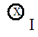

- A thin 1.3 m long copper wire has a mass of 0.09 kg and is levitated in a uniform magnetic field of 1.4 T.

  - On the diagram above show all the applied forces on the wire.
  - What is the net force on the wire if it stays at the same altitude?
  - On the diagram above show the direction of the magnetic field.
  - What is the magnitude of the current flowing through the wire?

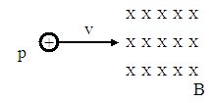

- A proton is traveling horizontally at a constant speed of 7.40 x 10⁶ m/s when it enters a uniform magnetic field of 0.460 T (see figure above).

  - On the diagram above show the direction of the magnetic force on the proton as it enters the magnetic field.
  - On the diagram above show an approximate path of the proton.
  - Calculate the magnitude of the magnetic force on the proton.
  - Calculate the acceleration of the proton.
  - Calculate the radius of the path that the proton follows in the magnetic field.

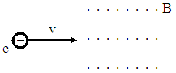

- An electron travels horizontally at a constant speed of 9.40 x 10⁶ m/s and enters a uniform magnetic field of 0.370 T (see figure above).

  - On the diagram above show the direction of the magnetic force on the electron as it enters the magnetic field.
  - On the diagram above show an approximate path of the electron.
  - Calculate the magnitude of the magnetic force on the electron.
  - Calculate the acceleration of the electron.
  - Calculate the radius of the path that the electron follows in the magnetic field.

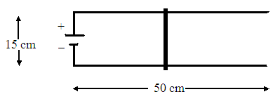

- The above diagram illustrates the basic design of a “rail gun”. A very light rod with a mass of 2.60 g and a length of 15.0 cm can move without friction on two parallel horizontal rails. The two rails are connected to a power supply, that can provide a constant current of 5.00 A, and are located in a perpendicularly oriented uniform 0.0400 T magnetic field.

  - On the diagram above show the direction of the conventional current in the rod.
  - In what direction must the field be oriented in order to accelerate the rod to the right? (show this direction on the diagram)
  - What is the magnitude of the magnetic force on the rod?
  - What is the acceleration of the rod?
  - What is the velocity of the rod as it leaves the rails?
  - How much time does it take for the rod to reach the edge of the rails?

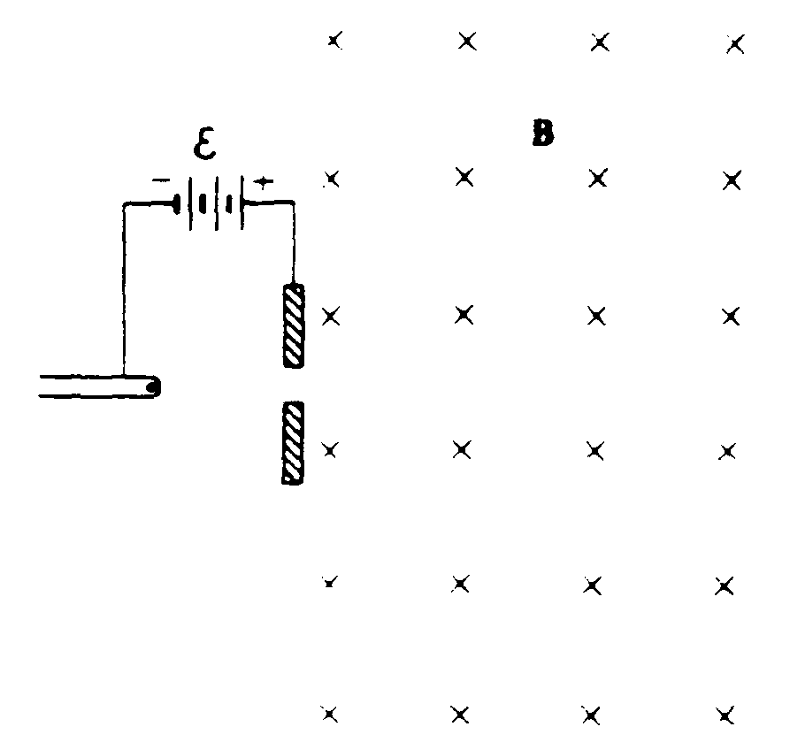

- An electron from a hot filament in a cathode ray tube is accelerated through a potential difference, ε. It then passes into a region of uniform magnetic field B, directed into the page as shown above. The mass of the electron is m and the charge has magnitude e.

- Find the potential difference ε necessary to give the electron a speed v as it enters the magnetic field.
- On the diagram above, sketch the path of the electron in the magnetic field.
- In terms of mass m, speed v, charge e, and field strength B, develop an expression for r, the radius of the circular path of the electron.
- An electric field E is now established in the same region as the magnetic field, so that the electron passes through the region undeflected.
  - Determine the magnitude of E.
  - Indicate the direction of E on the diagram above.

Answers to Chapter Questions
- Objects need to be rubbed to transfer electrons which will cause the Electric force. Certain objects naturally exert Magnetic forces.
- Each piece will have a north and a south pole. No matter how many times you cut the magnet, each remaining piece will have a north and south pole.
- No. Magnetism originates in the atom, so every object has a north and a south pole.
- Magnetic Field lines form a complete loop and at any point describe the direction that the north pole on a magnet will point. On a magnet, the lines leave the north pole and terminate on its south pole. The lines continue through the magnet to complete the loop.
- A Magnetic Field circles the current.
- A dot. An X.
- Zero. A maximum magnetic force = qvB.
- The forces are in the opposite directions, but are of the same magnitude; as the force is not dependent on the mass of the charged particles.
- Zero.
- The wire will deflect.
- The wires attract. The wires repel.
- To separate out charged particles of different masses.

Answers to Chapter Problems  - 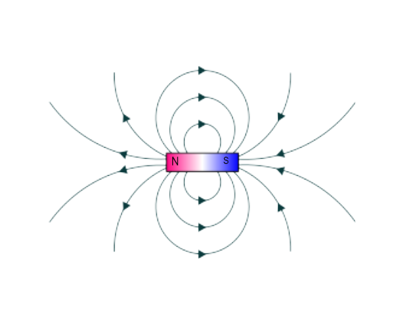  - 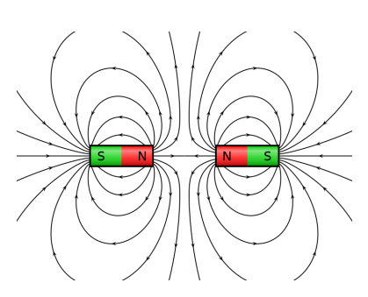  - 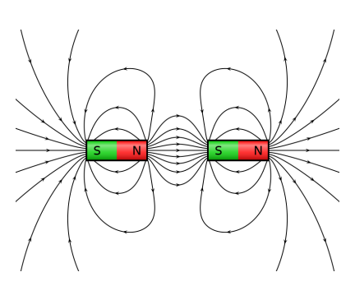  - Towards the top of the page.  - Concentric circles in a counter clockwise direction centered on the wire.  - Into the page. | - Out of the page  - Towards the bottom of the page.  - Concentric circles in a clockwise direction centered on the wire.  - Into the page.  - Into the page.  - 2.6 x 10⁻¹⁵ N to the left.  - 1.1 x 10⁻¹⁵ N into the page.  - 2.3 x 10⁻¹⁴ N towards the south.  - 7.4 T towards the east.  - 9.4 x 10⁻² T towards the north.  - 3.1 x 10¹³ m/s² towards the west.  - 4.7 x 10¹⁴ m/s² out of the page (+z).  - 4.2 x 10⁻¹⁴ N downwards.  - 21 N  - 16 N  - 2.2 x 10⁻³ T  - 2.9 x 10⁻³ T  - 19 A  - 12 A  - 5.3 x 10⁻³ m  - 1.2 x 10⁻² m  - 5 x 10⁻⁷ T  - 3.0 x 10⁻⁶ T into the page.  - 1.2 x 10⁻⁶ T into the page.  - 1.6 x 10⁻⁶ T out of the page.  - 1.9 x 10⁻¹ N towards each other.  - 7.9 x 10⁻⁵ N away from each other.  - 3.4 x 10⁻⁴ N away from each other.  - 1.0 x 10⁻³ N towards each other.
Answers to General Problems

1.

mg
$$F_{B}$$
- $ΣF=ma=0$
$$ΣF=0$$

B directed into the page
- $F_{B}-mg=ma=0 F_{B}=mg$
$$F_{B}=IBL$$
$$IBL=mg$$
$$I=\frac{mg}{BL}=\frac{\left(.15 kg\right)\left(9.8 m/s^{2} \right)}{\left(1.2 T\right)\left(2.4 m\right)}=0.51 A$$

2.

mg
I
$$F_{B}$$

- $ΣF=ma$
$F_{B}-mg=ma=0 F_{B}=mg$
$$ΣF=0$$

B
mg
I
$$F_{B}$$
- $F_{B}=mg$
$$F_{B}=IBL$$
$$IBL=mg$$
$$I=\frac{mg}{BL}=\frac{\left(.09 kg\right)\left(9.8 m/s^{2} \right)}{\left(1.4 T\right)\left(1.3 m\right)}= 0.48 A$$

3.

$$F_{B}$$
v
+

$$F_{B}$$
v
+
Circular path in a counter-clockwise direction

- $F_{B}=qvB=\left(1.6 ×{10}^{-19}\right)\left(7.40×{10}^{6}\frac{m}{s}\right)(.460 T)=5.44 ×{10}^{-13} N$
$$F_{B}=5.44 ×{10}^{-13} N$$

- $F_{B}=ma$
$$a=\frac{F_{B}}{m}=\frac{5.44 ×{10}^{-13} N}{1.67×{10}^{-27} kg}=3.26×{10}^{14} m/s^{2}$$
- $a=\frac{v^{2}}{r}$
$$r=\frac{v^{2}}{a}=\frac{{\left(7.40×{10}^{6}\frac{m}{s}\right)}^{2}}{3.26×{10}^{14} m/s^{2}}= 0.168m$$

4.

$$F_{B}$$
-

$$F_{B}$$
-
Circular path in a counter-clockwise direction

- $F_{B}=qvB=\left(1.6 ×{10}^{-19}\right)\left(9.40×{10}^{6}\frac{m}{s}\right)(.370 T)=5.56 ×{10}^{-13} N$
$$F_{B}=5.56 ×{10}^{-13} N$$
- $F_{B}=ma$
$$a=\frac{F_{B}}{m}=\frac{5.56 ×{10}^{-13} N}{9.11×{10}^{-31} kg}=6.10×{10}^{17} m/s^{2}$$
- $a=\frac{v^{2}}{r} r=\frac{v^{2}}{a}=\frac{{\left(9.40×{10}^{6}\frac{m}{s}\right)}^{2}}{6.10×{10}^{17} m/s^{2}}= 1.45×{10}^{-4} m$

5.
- b)
$$F_{B}$$
I
15 cm
50 cm
-
+

- $F_{B}=IBL=\left(5.00 A\right)\left(.0400 T\right)\left(.150 m\right)= .0300 N$
- $F_{B}=ma$
$$a=\frac{F_{B}}{m}=\frac{.0300 N}{2.6×{10}^{-3} kg}=11.5 m/s^{2}$$
- $v^{2}={v_{o}}^{2}+2a∆x$ ; $v_{o}=0$
$$v=\sqrt{2a∆x }=\sqrt{2\left(11.5 m/s^{2}\right)\left(.500 m\right)}=3.40 m/s$$
- $v=v_{o}+at ; v_{o}=0$
$$t=\frac{v}{a}=\frac{3.40 m/s}{11.5 m/s^{2} }=0.296 s$$

6.
- $\frac{mv^{2}}{2e}$

- $\frac{mv}{eB}$
- i. $vB$
ii. down

