PSI Physics - Magnetism
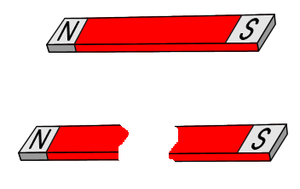
Multiple Choice Questions
- A bar magnet is divided in two pieces. Which of the following statements is true?
A. The bar magnet is demagnetized.
B. The magnetic field of each separated piece becomes stronger.
C. The magnetic poles are separated.
D. Two new bar magnets are created.
E. The electric field is created

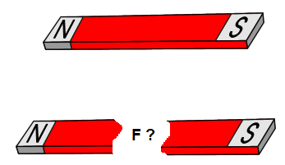
- A bar magnet is divided in two pieces. Which of the following statements is true about the force between the broken pieces if they face each other with a small separation?
A. There is an electric repulsive force between the broken pieces.
B. There is an electric attractive force between the broken pieces.
C. There is a magnetic repulsive force between the broken pieces.
D. There is a magnetic attractive force between the broken pieces.
E. There is no force between the broken pieces since they are demagnetized.

- Which of the following magnetic fields is correct for a single bar magnet?
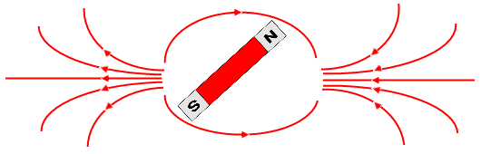
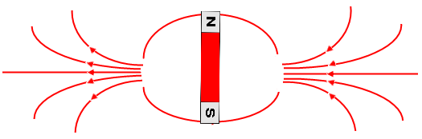

A. B.

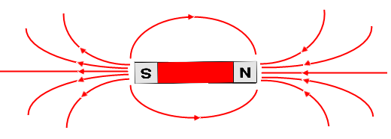
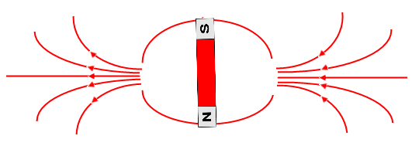

C. D.

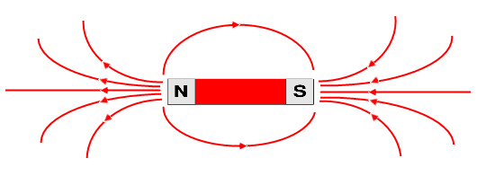

E.

- A DC current produces a/an:
A. Magnetic field.
B. Electric field.
C. Gravitational field.
D. Electromagnetic field.
E. None from the above.
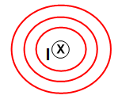
- An electric current flows into the page. What is the direction of the magnetic field?
A. To the bottom of the page.
B. To the top of the page.
C. Clockwise.
D. Counter-clockwise.
E. To the right.

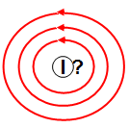
- A current-carrying wire is placed perpendicular to the page. Determine the direction of the electric current from the direction of the magnetic field.
A. Into the page.
B. Out of the page.
C. Clockwise.
D. Counter-clockwise.
E. To the left.

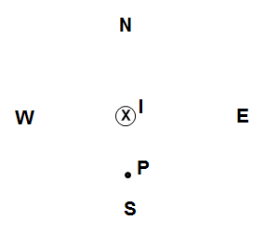

- A vertical wire carries an electric current into the page. What is the direction of the magnetic field at point P located to the south from the wire?
A. West.
B. North.
C. East.
D. South.
E. Down.

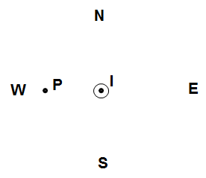
- A vertical wire carries an electric current out of the page. What is the direction of the magnetic field at point P located to the west from the wire?
A. West.
B. North.
C. East.
D. South.
E. Down.
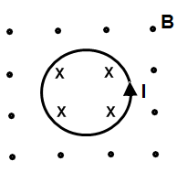
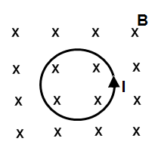
- Which of the following diagrams represents the magnetic field due to a circular current?
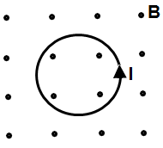

A. B. C.
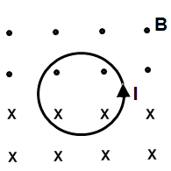
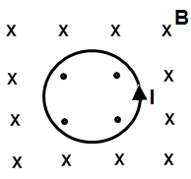

D. E.

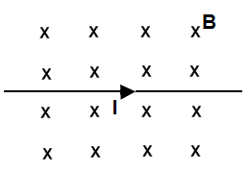
- A straight long wire carries an electric current to the right. The current is placed in a uniform magnetic field directed into the page. What is the direction of the magnetic force on the current?
A. Left.
B. Right.
C. To the bottom of the page.
D. To the top of the page.
E. Out of the page.

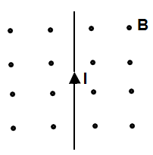
- A straight long wire carries an electric current to the top of the page. The current is placed in a uniform magnetic field directed out the page. What is the direction of the magnetic force on the current?
A. Left.
B. Right.
C. To the bottom of the page.
D. To the top of the page.
E. Out of the page

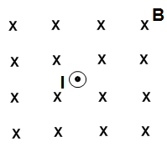
- A straight long wire carries an electric current out the page. The current is placed in a uniform magnetic field directed into the page. What is the direction of the magnetic force on the current?
A. Left.
B. Right.
C. To the bottom of the page.
D. To the top of the page.
E. There is no magnetic force on the current.

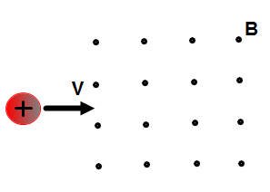
- A positive charge moving with a constant velocity v enters a region of a uniform magnetic field pointing out the page. What is the direction of the magnetic force on the charge?
A. Left.
B. Right.
C. To the bottom of the page.
D. To the top of the page.
E. There is no magnetic force on the current.

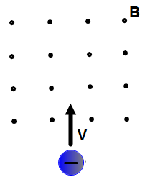

- A negative charge moving with a constant velocity v enters a region of a uniform magnetic field pointing out the page. What is the direction of the magnetic force on the charge?
A. Left.
B. Right.
C. To the bottom of the page.
D. To the top of the page.
E. There is no magnetic force on the current.

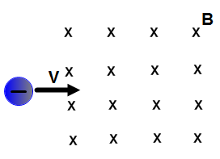
- A negative charge moving with a constant velocity v enters a region of a uniform magnetic field pointing into the page. What is the direction of the magnetic force on the charge?
A. Left.
B. Right.
C. To the bottom of the page.
D. To the top of the page.
E. There is no magnetic force on the current.
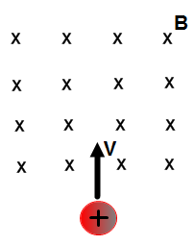
- A positive charge moving with a constant velocity v enters a region of a uniform magnetic field pointing into the page. What is the direction of the magnetic force on the charge?
A. Left.
B. Right.
C. To the bottom of the page.
D. To the top of the page.
E. There is no magnetic force on the current.

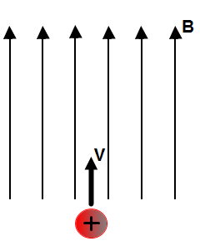

- A positive charge moving with a constant velocity v enters a region of a uniform magnetic field pointing to the top of the page. What is the direction of the magnetic force on the charge?
A. Left.
B. Right.
C. To the bottom of the page.
D. To the top of the page.
E. There is no magnetic force on the charge.

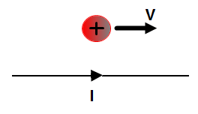
- A positive charge moves in parallel to a current carrying wire. What is the direction of the magnetic force on the charge?
A. Left.
B. Right.
C. To the bottom of the page.
D. To the top of the page.
E. There is no magnetic force on the charge.

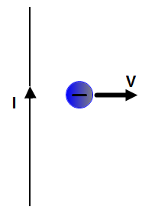
- A negative charge moves away from a current carrying wire. What is the direction of the magnetic force on the charge?
A. Left.
B. Right.
C. To the bottom of the page.
D. To the top of the page.
E. There is no magnetic force on the charge.

- A vertical wire carries an electric current into the page. An electron approaches the current from east. What is the direction of the magnetic force on the electron?
A. East.
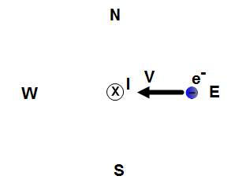
B. West.
C. North.
D. South.
E. Into the page.

Answers
1) D
2) D
3) E
4) A
5) C
6) B
7) A
8) D
9) D
10) D
11) B
12) E
13) C
14) A
15) C
16) A
17) E
18) C
19) C
20) E

