Circular Motion Multiple Choice Homework
PSI Physics Name____________________________________
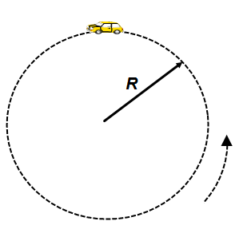
- A car moves around a circular path of a constant radius at a constant speed. Which of the following statements is true?
  - The car’s velocity is constant
  - The car’s acceleration is constant
  - The car’s acceleration is zero
  - The car’s velocity is directed toward the center
  - The car’s acceleration is directed toward the center

- A car moves around a circular path of a constant radius at a constant speed. When the car is at the top of the circular path, what is the direction of the velocity?
A. B. C.

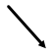

D. E.

- A car moves around a circular path of a constant radius at a constant speed. When the car is at the top of the circular path, what is the direction of the acceleration?
A. B. C.

D. E.

- An object moves in a circular path at a constant speed. Which of the following is true?
A. The car’s acceleration is zero because it has a constant speed
B. The car’s acceleration is not zero and causes the car to slow down
C. The car’s acceleration is not zero and causes the car to speed up
D. The car’s acceleration is not zero and causes the change in the direction of the car’s velocity
E. None from the above

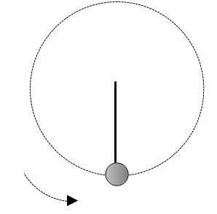
- A small sphere is swung in a vertical circle. Which of the following combinations represents the direction of the velocity and acceleration at the bottom of the circle?
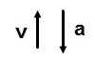
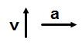
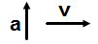
A. B. C.

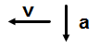
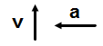
D. E.

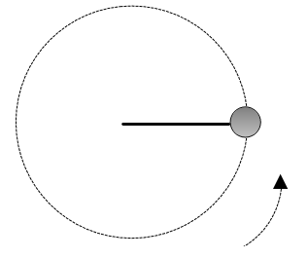

- A small sphere is swung in a vertical circle. Which of the following combinations represents the direction of the velocity and acceleration at the right-most point of the cirlce?
A. B.

C. D.

E.

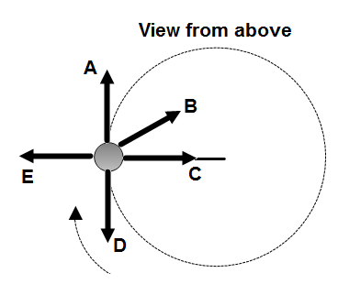

- An object experiences a uniform circular motion in a horizontal plane, as illustrated to the right. The direction of the net force is:

A. A B. B C.C

D. D E. E

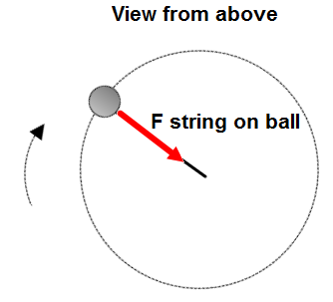
- A small ball attached to the end of a string experiences a uniform circular motion on a horizontal frictionless table. In order to keep the ball moving in a circle the string must apply force on the ball toward the center of the circle. Which of the following refers to a reaction force?
A. The force of gravity pulling down
B. The normal force pushing up
C. The force applied by the ball on the table
D. The force applied by the ball on the string
E. The force applied by the table on the ball

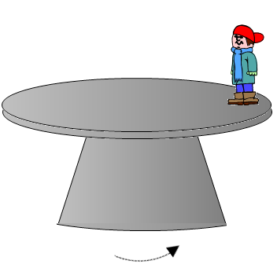

- A boy stands at the edge of a rotating table. Which of the following forces prevents him from sliding off the table?
A. The force of gravity
B. The normal force
C. The static friction
D. The kinetic friction
E. None from the above

- A boy stands at the edge of a rotating table. In order to keep him moving in a circular path the table applies a certain force on the boy. Which of the following is the reaction force to this force?
A. The normal force on the boy
B. The force of gravity exerted on the boy by Earth
C. The force of gravity exerted on Earth by the boy
D. The force exerted on the table by the boy that is directed straight down
E. The static friction force exerted by the boy on the table

- An object travels in a circular path of radius r at a constant speed v. What happens to the object’s acceleration if the radius of the circle is doubled and the speed stays unchanged?
A. It doubles
B. It quadruples
C. It is cut to a half
D. It is cut to a quarter
E. Stays unchanged

- An object travels in a circular path of radius r at a constant speed v. What happens to the object’s acceleration if the speed is doubled and the radius stays unchanged?
A. It doubles
B. It quadruples
C. It is cut to a half
D. It is cut to a quarter
E. Stays unchanged

- An object travels in a circular path of radius r at a constant speed v. What happens to the object’s acceleration if the radius of the circle is quadrupled and the speed is doubled?
A. It doubles
B. It quadruples
C. It is cut to a half
D. It is cut to a quarter
E. Stays unchanged

- An object moves at a constant acceleration a in a circular path of radius r. Which of the following is the object’s velocity?
A. $a×r$
B. $\frac{a}{r}$
C. $\frac{r}{a}$
D. $\sqrt{a×r}$
E. $\sqrt{\frac{a}{r}}$

- An object moves around a circular path at a constant speed and makes five complete revolutions in 20 seconds. What is the period of rotation?
A. 5 s B. 10 s C. 4 s D. 20 s E. 15 s

- An object moves around a circular path at a constant speed and makes ten complete revolutions in 5 seconds. What is the frequency of rotation?
A. 2 Hz B. 4 Hz C. 6 Hz D. 10 Hz E. 20 Hz

- An object rotates with a period of 10 s. How many revolutions will it make in 25 s?
A. 10 B. 15 C. 5 D. 2.5 E. 2

- An object rotates with a frequency of 300Hz. How many revolutions will it make in 15 s?
A. 1000 B. 1500 C. 2000 D. 3500 E. 4500

- An object rotates with a period of 0.5 s. What is the frequency of rotations?
A. 1.0 Hz B. 1.5 Hz C. 2.0 Hz D. 2.5 Hz E. 3.0 Hz

- An object rotates with a frequency of 50 Hz. What is the period of rotations?
A. 0.02 s B. 0.15 s C. 0.25 s D. 0.05 s E. 0.03 s

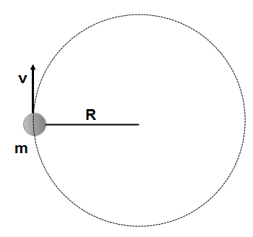
- A ball of mass m moves at a constant speed v in circular path with a radius R. Which of the following represents the net force applied on the ball?
A. $mvR$ B. $\frac{mv}{R}$ C. $\frac{mv^{2}}{R}$

D. $\frac{v^{2}}{R}$ E. $\frac{R}{mv}$

- An object of mass m moves at a constant speed v around a circular path of radius r. The net force applied to the object is F. What happens to the net force if the speed is doubled and the radius remains the same?
A. It doubles
B. It quadruples
C. Stays the same
D. Is cut to one-half
E. Is cut to one-quarter

- An object of mass m moves at a constant speed v around a circular path of radius r. The net force applied on the object is F. What happens to the net force if speed is doubled and radius is quadrupled?
A. It doubles
B. It quadruples
C. Stays the same
D. It is cut to one-half
E. It is cut to one-quarter
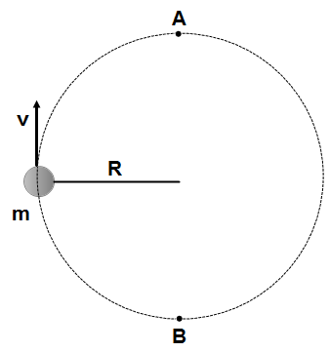

- A ball of mass m attached to a light string moves at a constant speed v in a vertical circle with a radius R. Which of the following is true about the magnitude of the net force at point A compared to that at point B?
A. The net force at point A is greater than at point B
B. The net force at point A is less than at point B
C. The net force is zero at all points around the circle
D. The net force at point A is equal to the net force at point B

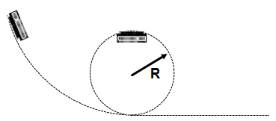
- A roller coaster car moves on a track with one section that is a vertical circular loop of radius R. When the car is at the top of the loop it just maintains contact with the track. What is the car’s acceleration at this point?
A. g upward
B. 0.5 g upward
C. Zero
D. 0.5 g downward
E. g downward

- A roller coaster car moves on a track with one section that is a vertical circular loop of radius R. When the car is at the top of the loop it just maintains contact with the track. What is the car’s velocity at this point?
A. $Rg$ B. $\frac{g}{R}$ C. $Zero$
D. $\frac{R}{g}$ E. $\sqrt{Rg}$

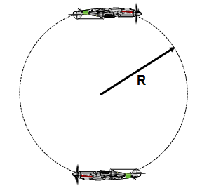
- *A pilot performs a vertical maneuver around a circle with a radius R. Which of the following is true about the pilot’s apparent weight?
A. It increases when he moves from the lowest to the highest point of the circle
B. It decreases when he moves from the lowest to the highest point of the circle
C. It decreases when he moves from the highest to the lowest point of the circle
D. Remains constant at all points
E. More information is required

- *A pilot performs a vertical maneuver around a circle with a radius R. When the airplane is at the lowest point of the circle the pilot’s apparent weight is 6 mg. What is the acceleration of the plane at the lowest point?
A. g B. 2 g C. 3 g D. 4 g E. 5 g

- *A pilot performs a vertical maneuver around a circle with a radius R. When the airplane is at the lowest point of the circle pilot’s weight is 4 mg. What is the velocity at the lowest point?
A. $\sqrt{Rg}$
B.$\sqrt{2Rg}$
C.$\sqrt{3Rg}$
D.$\sqrt{4Rg}$
E. $\sqrt{5Rg}$

- *A coin lies on the top of a turntable at a distance R from the center. The table rotates at a constant speed v. What is the minimum coefficient of static friction that can prevent the coin from sliding of the table?
A. $vrg$ B. $\frac{Rg}{v^{2}}$ C.$\frac{v}{Rg}$ D.$\frac{v^{2}}{Rg}$ E.$\sqrt{vRg}$

Multiple Choice Answers
- E
- C
- B
- D
- B
- D
- C
- D
- C
- E
- C
- B
- E
- D
- C
- A
- D
- E
- C
- A
- C
- B
- C
- D
- E
- E
- *B
- *E
- *C
- *D

