Universal Gravitation Multiple Choice Homework
PSI Physics Name____________________________________
Multiple Choice Questions

- The discovery of “Universal Gravitation” is associated with:
A. Robert Hook
B. Isaac Newton
C. James Joule
D. Max Plank
E. Christian Huygens

- Two objects with equal masses of 1 kg each are separated by a distance of 1 m. The gravitational force between the objects is:
A. Slightly less than G
B. Slightly greater than G
C. Equal to G
D. Half as much as G
E. Twice as much as G

- Two objects, one with a mass of m and one with a mass of 4m are attracted to each other by a gravitational force. If the force on 4m is F, what is the force on mass m in terms of F?
A. 16F B. 4F C. F D. ¼F E. 1/16F

- An apple hangs on a tree on the Earth. Which of the following statements is correct?
- The force on the apple is greater than the force on the Earth because the Earth is more massive.
- The force on the Earth is greater than the force on the apple because the Earth is more massive.
- The force on the apple is less than the force on the Earth because the tree is supporting the apple.
- The forces on the apple and Earth are equal.
- The forces on the apple and the Earth are zero because they are not touching each other.

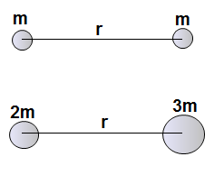

- Two objects are attracted to each other by a gravitational force F. If one mass is doubled and the other is tripled without changing the distance, what is the new gravitational force between the objects in terms of F?
A. 4F B. 9F C. 6F D. 1/9F E. 1/6F

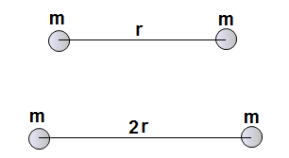

- Two objects are attracted to each other by a gravitational force F. If the distance between the objects is doubled, what is the new gravitational force between the objects in terms of F?
A. 4F B. 9F C. 16F D. 1/9F E. 1/4F

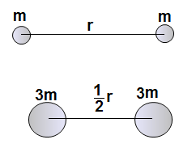

- Two objects are attracted to each other by a gravitational force F. If each mass is tripled and the distance between the objects is cut in half, what is the new gravitational force between the objects in terms of F?
A. 24F B. 36F C. 16F D. 1/16F E. 1/24F

- An object with a mass of 48 kg measured on Earth is taken to the Moon. What is the mass of the object on the Moon’s surface if the acceleration due to gravity on the Moon is one-sixth of that on Earth?
A. 8 kg B. 48 kg C. 288 kg D. 480 kg E. 80 kg

- An object with a mass of 48 kg measured on Earth is taken to the Moon. What is the weight of the object on the Moon’s surface if the acceleration due to gravity on the Moon is one-sixth of that on Earth?
A. 8 N B. 48 N C. 288 N D. 480 N E. 80 N

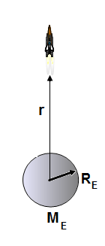
- A rocket moves away from the surface of Earth. As the distance r from the center of the planet increases, what happens to the force of gravity on the rocket?
A. The force increases directly proportional to r
B .The force increases directly proportional to $r^{2}$
C. The force doesn’t change
D. The force becomes zero after the rocket loses the contact with Earth
E. The force decreases inversely proportional to $\frac{1}{r^{2}}$

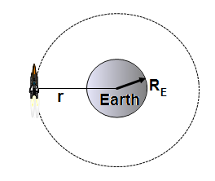

- A spacecraft is orbiting Earth with an orbital radius r. Which of the following is true about the astronaut’s apparent weight?
A. The apparent weight is slightly less than the weight on the surface
B. The apparent weight is slightly greater than the weight on the surface
C. The apparent weight is the same as the weight on the surface
D. The apparent weight is zero because the astronaut is in a free fall
E. More information is required

- A spacecraft starts on Earth is moving to Mars. Which of the following is correct about the gravitational force on the spacecraft due to Earth’s attraction?
A. The force becomes zero when the spacecraft is half way between the planets
B. The force becomes zero when the spacecraft is closer to the surface of Mars
C. The spacecraft is never beyond the Earth’s gravitational attraction
D. The force becomes zero when the spacecraft land on the surface of Mars
E. More information is required
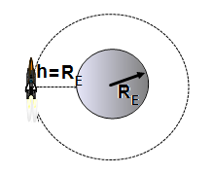

- A satellite is orbiting Earth at a distance h = R_{E} above the surface. What is the centripetal acceleration of the satellite compared to that on the surface?
A. a = $\frac{g}{4}$
B. a = $\frac{g}{2}$
C. a = g
D. a = 2g
E. a = 4 g

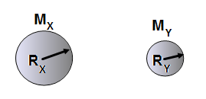

- *What is the ratio between the acceleration due to gravity of two hypothetical planets X and Y, if the mass of the planet X is three times greater than the mass of the planet Y, and the radius of the planet X is twice greater of the radius of the planet Y.
A. $\frac{g_{x}}{g_{y}}$ = $\frac{3}{4}$
B.$\frac{g_{x}}{g_{y}}$ = $\frac{4}{3}$
C.$\frac{g_{x}}{g_{y}}$ = $\frac{1}{4}$
D.$\frac{g_{x}}{g_{y}}$ = $\frac{3}{1}$
E.$\frac{g_{x}}{g_{y}}$ = $\frac{4}{1}$

- *A hypothetical planet has a mass of four times that of the Earth and radius of twice that of the Earth? What is the acceleration due to gravity on the planet in terms of the acceleration on the Earth?
A. g B. $\frac{g}{2}$ C.$\frac{g}{4}$ D. 2g E.$\frac{g}{8}$

- *Two planets X and Y have the same surface gravity, but planet X has four times the mass of planet Y. What is the radius of planet X in terms of the radius of planet Y?
A. R_{x} = 4 R_{y} B. R_{x} = 16 R_{y} C. R_{x} = 8 R_{y} D. R_{x} = 2 R_{y} E. R_{x} = $\frac{1}{2}$ R_{y}

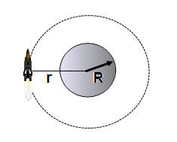

- **A satellite is orbiting a planet of mass M with an orbital radius r. Which of the following represents the orbital velocity of the satellite?
A. v = $\sqrt{\frac{GM}{R}}$ B. v = $\sqrt{\frac{GM}{r^{2}}}$ C. v = $\sqrt{\frac{GM}{r}}$ D. v = $\sqrt[3]{\frac{GM}{r}}$ E. v = $\sqrt{\frac{GM}{r^{3}}}$

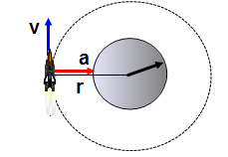
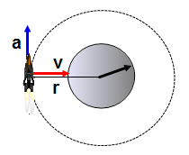
- **A satellite is orbiting a planet with an orbital radius r. Which of the following diagrams represents the direction of the velocity and acceleration of the satellite?

A. B.

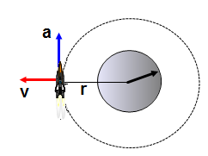
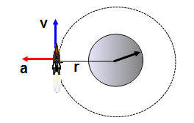

C. D.

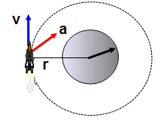

E.

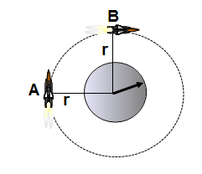

- **A satellite A has twice the mass of satellite B. The satellites orbit a planet with the same orbital radius. The orbital velocity of the satellite A compared to B is:
A. Twice greater
B. Four times greater
C. Half as much
D. One-quarter as much
E. The same
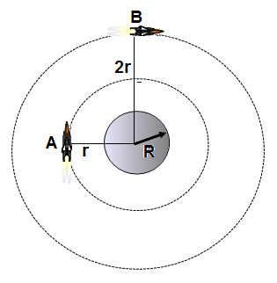

- **Two satellites A and B orbit the same planet. Satellite B moves in circular orbit with twice greater radius than satellite A. What is the orbital velocity of satellite B compared to the velocity of A?
A. v_{A} =$\frac{1}{\sqrt{2}}$ v_{B}
B. v_{A} = $\frac{1}{2}$v_{B}
C. v_{A} = $\frac{\sqrt{2}}{1}$v_{B}
D. v_{A} = $\frac{1}{4}$v_{B}
E. v_{A} = $\frac{2}{1}$v_{B}

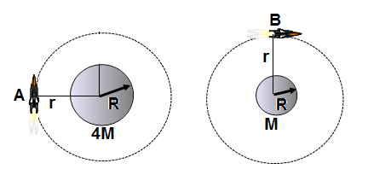

- **A satellite A moves around a planet of mass 4M, another satellite B moves around a planet of mass M. What is the orbital period of satellite A in terms of that of satellite B if the orbital radius is the same for both cases?
A. T_{A} = $\frac{1}{4}$T_{B}
B. T_{A} = $\frac{1}{\sqrt{2}}$T_{B}
C. T_{A} = $\frac{1}{2}$T_{B}
D. T_{A} = 2T_{B}
E. T_{A} = 4T

Answer Key
- B
- C
- C
- D
- C
- E
- B
- B
- E
- E
- D
- C
- A
- *A
- *A
- *D
- **C
- B
- **E
- **C
- **C

