Electric Charge & Force
Multiple Choice Questions
PSI Physics Name____________________________________

- Which of the following is the correct force between two negative charges?

A.

B.

C.

D.

E.

- Which of the following is the correct force between two positive charges?

A.

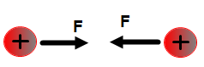

B.

C.

D.

E.

- Which of the following is the correct force between one positive charge and one negative charge?

A.

B.

C.
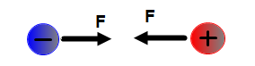

D.

E.

- A plastic rod is rubbed with a piece of animal fur. The plastic rod acquires a negative charge during this process. Which of the following is true about the charge on the piece of fur?
A. It acquires a positive charge but greater in magnitude than the rod
B. It acquires a positive charge but less in magnitude than the rod
C. It acquires a negative charge but greater in magnitude than the rod
D. It acquires a negative charge but less in magnitude than the rod
E. It acquires a positive charge with the same magnitude as the rod

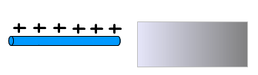

- A positively charged rod is brought close to one end of a neutral metallic plate. What type of charge is induced on the closest side of the plate?
A. Positive
B. Negative
C. Neutral
D. It depends of the separation between the rod and plate
E. More information about the type of metal is required

- A positively charged rod is brought close to one end of a neutral metallic plate. What type of charge is induced on the farthest side of the plate?
A. Positive
B. Negative
C. Neutral
D. It depends of the separation between the rod and plate
E. More information about the type of metal is required

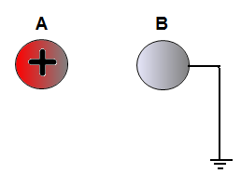

- A positively charged sphere A is brought close without touching to a neutral sphere B. Sphere B is touched with a grounded wire. What is the charge on sphere B after the wire is removed?
A. Positive
B. Negative
C. It stays neutral
D. It depends on the contact time
E. It depends on the material that sphere B is made of

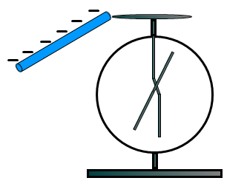
- A neutral electroscope is touched with a negatively charged rod. What is the charge on the electroscope after the rod is removed?
A. Positive
B. Negative
C. It stays neutral
D. It depends on the contact time
E. It depends on the material that the electroscope is made of

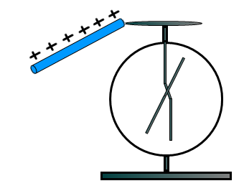
- A neutral electroscope is touched with a positively carged rod. After the rod is removed the electroscope is charged positively because of:
A. Induction
B. Conduction
C. Thermoemission
D. Photoemission
E. None from the above

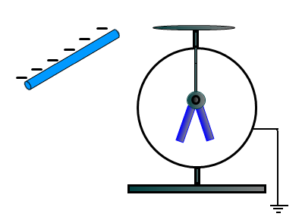
- A negatively charged rod is brought near an uncharged, grounded electroscope. Which of the following statements is true?
A. The positive charge flows from the electroscope to the ground
B. The positive charge flows from the ground to the electroscope
C. The negative charge flows from the electroscope to the ground
D. The negative charge flows from the ground to the electroscope
E. The electroscope stays neutral because the rod doesn’t touch it

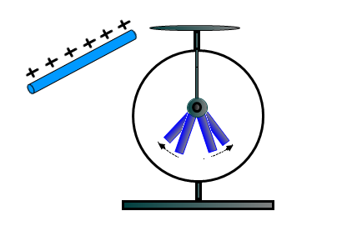
- A positively charged rod is brought near a charged electroscope. As a result of doing this, the electroscope leaves move further apart. What is the charge on the electroscope?
A. Positive
B. Negative
C. It is neutral
D. It depends on the distance between the electroscope and the rod
E. It depends on the material that the electroscope is made of

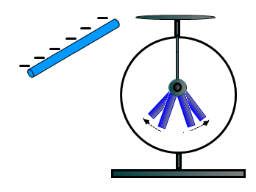
- A negatively charged rod is brought near a charged electroscope. As a result of doing this, the electroscope leaves move further apart. What is the charge on the electroscope?
A. Positive
B. Negative
C. It is neutral
D. It depends on the distance between the electroscope and the rod
E. It depends on the material that the electroscope is made of

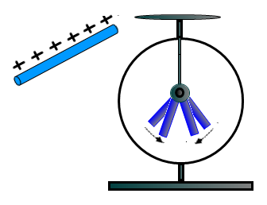
- A positively charged rod is brought near a charged electroscope. As a result of doing this, the electroscope leaves move closer to each other. What is the charge on the electroscope?
A. Positive
B. Negative
C. It is neutral
D. It depends on the distance between the electroscope and the rod
E. It depends on the material that the electroscope is made of

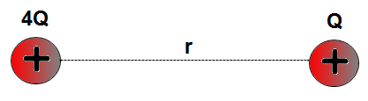

- Two positive charges with magnitudes 4Q and Q are separated by a distance r. Which of the following statements is true?
A. The charge with a greater magnitude exerts a larger force on the small charge
B. The charge with a greater magnitude exerts a smaller force on the small charge
C. The forces on each charge are the same in magnitude and opposite in direction
D. The forces on each charge are the same in magnitude and pointing in the same direction

- Sphere A is charged positively and sphere B is neutral. The spheres are brought near each other. Which of the following statements is true?
A. There is no electrostatic force between the spheres since one is neutral
B. There is a repulsive electrostatic force between the spheres
C. There is an attractive electrostatic force between the spheres
D. There is a repulsive electrostatic force applied only on sphere B
E. More information is required

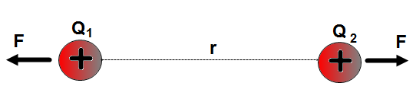

- Two positive charges Q₁ and Q₂ are separated by a distance r. The charges repel each other with a force F. If the magnitude of each charge is doubled and the distance stays unchanged what is the new force between the charges?
A. F B. 2 F C. 4 F D. $\frac{1}{4}$F E. $\frac{1}{2}$F

- Two positive charges Q₁ and Q₂ are separated by a distance r. The charges repel each other with a force F. If the distance between the charges is cut to one-fourth what is the new force acting on each charge?
A. 16 F B. 2 F C. 4 F D. $\frac{1}{4}$F E. $\frac{1}{2}$F

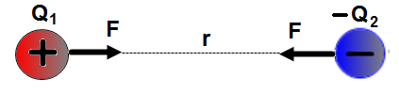

- Two charges Q₁ and –Q₂ are separated by a distance r. The charges attract each other with a force F. What is the new force between the charges if the distance is tripled?
A. 16 F B. 2 F C. 4 F D. $\frac{1}{4}$F E. $\frac{1}{9}$F

- Two charges Q₁ and –Q₂ are separated by a distance r. The charges attract each other with a force F. What is the new force between the charges if the distance is cut to one-fourth and the magnitude of each charge is doubled?
A. 16 F B. 64 F C. 48 F D. $\frac{1}{48}$F E. $\frac{1}{64}$F

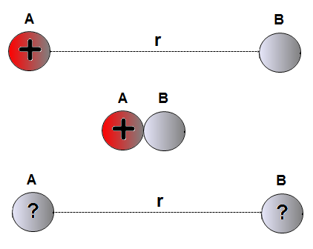

- Sphere A carries a positve charge 4Q and sphere B is neutral. Initially the spheres are separated by a distance r. The spheres briefly touch each other and move to the initial separation. What is the new charge on each sphere?
A. Q B. 4Q C. $\frac{1 }{4}$Q D. $\frac{1}{2}$Q E.2Q

- Sphere A caries a positve charge 4Q and sphere B is neutral. Initially the spheres are separated by a distance r. The spheres briefly touch each other and move to the initial separation. Which of the following is the correct expression for the force on each sphere after they moved to the original distance r?
A. F = $\frac{kQ^{2}}{r^{2}}$ B. F = $\frac{2kQ^{2}}{r^{2}}$ C. F = $\frac{8kQ^{2}}{r^{2}}$

D. F = $\frac{4kQ^{2}}{r^{2}}$ E. F = $\frac{kQ^{2}}{2r^{2}}$

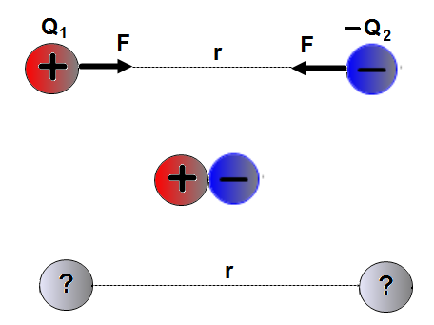

- A positively charged sphere with a charge of +8Q is separated from a negatively charged sphere -2Q by a distance r. The spheres briefly touch each other and move to the original distance r. What is the new charge on each sphere after they move to the distance r?
A. Q B. 2Q C. 3Q
D. $\frac{1}{2}$ Q E. $\frac{1 }{4}$Q

- A positively charged sphere with a charge of +8Q is separated from a negatively charged sphere -2Q by a distance r. There is an attractive force F exerted on each sphere. The spheres briefly touch each other and move to the original distance r. What is the new force on each sphere in terms of F?
A. $\frac{9}{16}$ F B. $\frac{16}{9}$ F C. $\frac{9}{4}$ F

D.$\frac{4}{9}$ F E. $\frac{2}{3}$ F

Answers
1. C
2. C
3. D
4. E
5. B
6. A
7. B
8. B
9. B
10.C
11.A
12.B
13.B
14.C
15.C
16.C
17.A
18.E
19.B
20.E
21.D
22.C
23.A

