Chapter Questions

- What is the definition of the Electric Field and what equation was used to derive this concept?

- Why can Electric Field lines never cross or touch each other? Do Electric Field lines exist?

- Draw the electric field lines around a positive charge. How would these lines be different if the charge was negative?

- What is the significance of the density of the electric field lines about a charge?

- Compare and contrast the Gravitational Field and the Electric Field.

- What is the dominant field that acts on two electrons that are 10⁻¹² m apart? Gravitational or Electric Field?

- How is the Electric Field due to several charges calculated?

- If there are two negative charges near each other, is the Electric Potential Energy positive or negative? What does this imply?

- If there is a negative charge near a positive charge, is the Electric Potential Energy of this arrangement negative or positive? What does this imply?

- How is the Electric Potential derived from the Electric Potential Energy?

- What is the unit for Electric Potential? Express this unit in terms of Joules and Coulombs. Explain what this means.

- What is an Equipotential line? How does it relate to an Electric Field line?

- How much work is required to move an electric charge between two points which have equal potential?

- Can two equipotential lines cross or touch in free space?

- Describe the Electric Field between two parallel plates of opposite charge. What is the value of the Electric Field outside the parallel plates?

Chapter Problems

- Electric Field

Classwork
- A 2.40 μC charge is subject to a 3.00 mN force due to an Electric Field. What is the magnitude of the Electric Field at the location of the charge?

- A 6.3 μC electric charge is placed in an Electric Field with a magnitude of 5.0 x 10⁵ N/C. What is the electric force on the charge due to the Electric Field?

- A 5.6 nC electric charge is placed in an Electric Field and experiences a force of 7.4 μN. What is the magnitude of the Electric Field at that location?

Homework
- What is the direction and magnitude of the Electric Field due to a -6.8 μC point charge at a distance of 7.4 m?

- An oil drop is charged negatively. How much charge is on the drop if the Electric Field is 6,400 N/C at a distance of 1.2 m?

- What is the direction and magnitude of the Electric Field 4.0 m away from an 8.6 μC charge?

- The Electric Field due to a charged particle is 3,600 N/C at a location 2.4 m away from the particle. How much electric charge is on the particle?

- *Electric Field relationship to Gravitational Field

Classwork
- Calculate and compare the gravitational force and the electrical force between two protons that are separated by 1.2 x 10⁻¹⁵ m (G = 6.67 x 10⁻¹¹ Nm²/kg², e = 1.60 x 10⁻¹⁹ C, m_{p} = 1.67 x 10⁻²⁷ kg).
- Calculate and compare the gravitational force and the electrical force between two electrons that are separated by 4.15 x 10⁻¹² m (G = 6.67 x 10⁻¹¹ Nm²/kg², e = 1.60 x 10⁻¹⁹ C, m_{e} = 9.11 x 10⁻³¹ kg).
- What is the magnitude of the Electric Field required to “levitate” an electron in the Earth’s gravitational field.

Homework
- Calculate and compare the gravitational force and the electrical force between two protons that are separated by 4.25x 10⁻¹⁵ m (G = 6.67 x 10⁻¹¹ Nm²/kg², e = 1.60 x 10⁻¹⁹ C, m_{p} = 1.67 x 10⁻²⁷ kg).
- Calculate and compare the gravitational force and the electrical force between two electrons that are separated by 9.45 x 10⁻¹² m (G = 6.67 x 10⁻¹¹ Nm²/kg², e = 1.60 x 10⁻¹⁹ C, m_{e} = 9.11 x 10⁻³¹ kg).
- What is the magnitude of the Electric Field required to suspend an oil drop of mass 1.0 x 10⁻⁴ kg with a charge of 6.2 x 10⁻⁶ C in the Earth’s gravitational field?

Electric Field of Multiple Charges

Classwork
- Draw the Electric Field line surrounding one single positive charge.

- Draw the Electric Field lines surrounding two positive electric charges that are in a horizontal line, separated by a distance, r.

- Draw the Electric Field lines surrounding a positive charge on the top and a negative charge below.

Homework
- Draw the Electric Field line surrounding one single negative charge.

- Draw the Electric Field lines surrounding two negative electric charges that are in a horizontal line, separated by a distance, r.

- Draw the Electric Field lines surrounding a negative charge on the left and a positive charge on the right.

The Net Electric Field

Classwork
+Q₁ +Q₂

-3 -2 -1 0 1 2 3 4 5 6 7 8 x(m)

- As shown in the above diagram, a positive charge, Q₁ = 2.6 μC, is located at a point, x₁ = -3.0 m, and a positive charge, Q₂ = 1.4 μC, is located at a point, x₂ = +4.0 m.
- Find the magnitude and direction of the Electric Field at the origin due to charge Q_{1.}
- Find the magnitude and direction of the Electric Field at the origin due to charge Q_{2.}
- Find the magnitude and direction of the net Electric Field at the origin.

+Q₁ -Q₂ +Q₃

-3 -2 -1 0 1 2 3 4 5 6 7 8 9 x(m)

21. A positive charge, Q₁ = 7.4 μC, is located at x₁ = -2.0 m, a negative charge Q₂ = -9.7 μC is located at a
point x₂ = 3.0 m and a positive charge Q₃ = 2.1 μC is located at a point x₃ = 9.0 m.
- Find the magnitude and direction of the Electric Field at the origin due to Q₁.
- Find the magnitude and direction of the Electric Field at the origin due to Q₂.
- Find the magnitude and direction of the Electric Field at the origin due to Q₃.
- Find the magnitude and direction of the net Electric Field at the origin.

Homework
-Q₁ +Q₂

-3 -2 -1 0 1 2 3 4 5 6 7 8 x(m)

- As shown in the above diagram, a charge, Q₁ = -3.6 μC, is located at a point, x₁ = -2.0 m, and a positive charge, Q₂ = 2.8 μC, is located at a point, x₂ = +6.0 m.
- Find the magnitude and direction of the Electric Field at the origin due to charge Q_{1.}
- Find the magnitude and direction of the Electric Field at the origin due to charge Q_{2.}
- Find the magnitude and direction of the net Electric Field at the origin.

+Q₁ -Q₂ -Q₃

-3 -2 -1 0 1 2 3 4 5 6 7 8 9 x(m)

23. A positive charge, Q₁ = 5.2 μC, is located at x₁ = -2.0 m, a negative charge Q₂ = -9.7 μC is located at a
point x₂ = 4.0 m and a negative charge Q₃ = -4.1 μC is located at a point x₃ = 9.0 m.
- Find the magnitude and direction of the Electric Field at the origin due to Q₁.
- Find the magnitude and direction of the Electric Field at the origin due to Q₂.
- Find the magnitude and direction of the Electric Field at the origin due to Q₃.
- Find the magnitude and direction of the net Electric Field at the origin.

Electric Potential Energy

Classwork
- What is the potential energy of an electron and a proton in a hydrogen atom if the distance between them is 5.3 x 10⁻¹¹ m?

- What is the potential energy of two charges of +4.2 μC and +6.1 μC which are separated by a distance of 50.0 cm?

- What is the potential energy of two charges of -3.6 μC and +5.2 μC which are separated by a distance of 75.0 cm?

- There are three charges, 4.0 µC, 3.5 µC and -6.4 µC, each at the vertex of an equilateral triangle of side length 0.020m. What is the potential energy of the system?

Homework
- What is the potential energy of two charges of -5.2 μC and -8.2 μC which are separated by a distance of 50 cm?

- What is the potential energy of two charges of 4.2 μC and -6.1 μC which are separated by a distance of 75.0 cm?

- What is the potential energy of two electrons that are separated by a distance of 3.5 x 10⁻¹¹ m?

- What is the potential energy of three charges of 2.0 µC, -4.5 µC and -3.4 µC that are in a straight line, with the -4.5 µC charge in the middle, and each charge is 5.0 cm away from its adjacent charge?

Electric Potential (Voltage)

Classwork
- Draw Equipotential lines due to a positive point charge.

- What is the electric potential 50.0 cm from a –7.4 μC point charge?

- What is the electric potential 25 cm from a +5.0 μC point charge?

- Two point charges of +3.5 μC and +8.3 μC are separated by a distance of 4.0 m. What is the electric potential midway between the charges?

- A proton passes through a potential difference of 350 V. Find its kinetic energy and velocity (e = 1.60 x 10⁻¹⁹ C, m_{p} = 1.67 x 10⁻²⁷ kg).

- How much work is done in moving a +2.6 µC charged particle from a point wth a potential of 100.0 V to a point with a potential of 20.0 V?

- An Electric Field does 40.0 mJ of work to move a +6.8 μC charge from one point to another. What is the potential difference between these two points?

Homework
- Draw Equipotential lines due to a negative point charge.

- What is the electric potential 65.0 cm from a –8.2 μC point charge?

- What is the electric potential 30.0 cm from a +6.8 μC point charge?

- Two point charges of +2.5 μC and -6.8 μC are separated by a distance of 4.0 m. What is the electric potential midway between the charges?

- An electron falls through a potential difference of 200.0 V. Find its kinetic energy and velocity (e = 1.60 x 10⁻¹⁹ C, m_{e} = 9.11 x 10⁻³¹ kg).

- An Electric Field does 25 mJ of work to move a +7.4 μC charge from one point to another. What is the potential difference between these two points?

- How much work is required by an Electric Field to move a -4.3 μC from a point with a potential 50.0 V to a point with a potential –30.0 V?

- An Electric Field does 150 μJ of work to move a –8.4 μC charge from one point to another? What is the potential difference between these two points?

Uniform Electric Field

Classwork
- Draw Equipotential lines in a uniform Electric Field, with the positive line of charge on the top, and the negative line of charge on the bottom.

- An Electric Field of 440 N/C is desired between two plates which are 4.6 mm apart; what voltage should be applied?

- What is the magnitude of the electric force on an electron in a uniform Electric Field of 2,500 N/C?

- A 240 V power supply creates an Electric Field of 4.5 x 10⁶ N/C between two parallel plates. What is the separation between the plates?

- A proton is accelerated by a uniform 360 N/C Electric Field. Find the kinetic energy and the velocity of the proton after it has traveled 50.0 cm.

- A uniform 450 N/C Electric Field moves a +3.4 μC charge 10.0 cm; how much work is done by the Electric Field?

- How much work is done by a uniform 760 N/C Electric Field on a proton in accelerating it through a distance of 60.0 cm?

- What is the magnitude and direction of the electric force on an electron in a uniform Electric Field of 4200 N/C that points due west? What is the acceleration of the electron?

Homework
- Draw Equipotential lines in a uniform Electric Field, with the negative line of charge on the top, and the positive line of charge on the bottom.

- How strong is the Electric Field between two metal plates 5.0 mm apart if the potential difference between them is 240 V?

- How much voltage should be applied to two parallel plates, which are 12 mm apart, in order to produce a 1500 N/C Electric Field between them?

- Two plates are connected to a 120 V battery which have a small air gap. How small can the gap be if the Electric Field cannot exceed the air’s breakdown value of 5.0 x 10⁶ N/C, causing a spark?

- An electron is released from rest in a uniform Electric Field and accelerates to the west at a rate of 2.4 x 10⁸ m/s². What is the magnitude and direction of the Electric Field?

- An electron falls a distance of 25 cm in a uniform 500.0 N/C Electric Field; how much work is done on the electron?

- A potential difference of 120 V is applied between two parallel plates. What is the Electric Field strength between the plates if they are 2.5 mm apart?

- An initially stationary electron is accelerated by a uniform 640 N/C Electric Field. Find the kinetic energy and velocity of the electron after it has traveled 15 cm.

General Problems

Classwork

1. A 0.20 g oil drop has a negative charge of –3.2 μC and remains stationary between two charged parallel plates.
- Draw the Electric Field line between the plates.
- Draw a free-body diagram and show all the forces acting on the drop.
- Find the magnitude of the Electric Field required between the plates to keeps the drop stationary.
- If the plates are 3.0 cm apart, what is the voltage difference between the plates?
- The mass of the drop decreases with time due to evaporation. Describe what will happen to the oil drop.

E
e

2. A 4.00 x 10³ N/C uniform Electric Field is directed towards the east. An electron is released from rest inside the field.
  - Draw free-body diagram and show the direction of the electric force acting on the electron.
  - Find the magnitude of the electric force on the electron.
  - Determine the acceleration of the electron.
  - What is the velocity of the electron after 5.00 ns?
  - How far will the electron travel in the first 3.00 ns?
  - What is the velocity of the electron after it has traveled 1.0 m?

D
A C

B E

+100V +50V 0V -50V -100V

3. In a region of space, the electric potential is described by the set of equipotential lines shown above. A –35.0 μC charge will be moved from one location to another in this region.
- On the diagram, indicate the Electric Field direction at the points: A, B, C, D and E.
- Between which two points is there the greatest potential difference?
- Between which two locations will the work done by the Electric Field on the charge be the greatest?
- How much work is done by the Electric Field on the charge if it moves from point B to point C?
- How much work is done by the Electric Field on the charge if it moves from point E to point D?
- Compare the magnitude of the work done on the charge when it moves from point A to point B; when it moves from point A to point E; and from point E to point B.

+Q₁ -Q₂

-4 -3 -2 -1 0 1 2 3 4 5 6 7 x(m)

4. A positive charge, Q₁ = +4.60 μC, is located at point x₁ = -4.00 m and a charge, Q₂ = -3.80 μC, is located at a point x₂ = 6.00 m.
  - Find the magnitude and direction of the electric force between the charges.
  - Find the magnitude and direction of the Electric Field at the origin due to charge Q₁.
  - Find the magnitude and direction of the Electric Field at the origin due to charge Q₂.
  - Find the magnitude and direction of the net Electric Field at the origin.
  - Find the electric potential at the origin due to charge Q₁.
  - Find the electric potential at the origin due to charge Q₂.
  - Find the net electric potential at the origin.
  - How much work must be done to bring a 1.00 μC test charge from infinity to the origin?

Homework

E

p

5. A proton is released, from rest, in a 2500 N/C uniform Electric Field which is directed towards the west.
- Draw a free-body diagram and show the direction of the force acting on the proton due to the field.
- Find the magnitude of the electric force on the proton.
- What is the acceleration of the proton?
- What is the velocity of the proton after 3.0 ns?
- How far will the proton have traveled in the first 7.0 $μ$s?
- What will the proton’s velocity be after it has traveled 0.8 m?

D
A
C E
B

-40V +40V
-20V 0V +20V

6. In a region of space, the electric potential is described by the set of equipotential lines shown above. A –35 μC charge will be moved from one location to another in this region.
- On the diagram, indicate the Electric Field direction at the points: A, B, C, D and E.
- Between which two points is there the greatest potential difference?
- Between which two locations will the work done by the Electric Field on the charge be the greatest?
- How much work is done by the Electric Field on the charge if it moves from point A to point D?
- How much work is done by the Electric Field on the charge if it moves from point C to point A?
- The charge is moved from point A to point B in the first trial. In the second trial, the charge is moved from point A to point E, and then it is moved to point B. Compare the magnitude of the work done on the charge between the two trials.

-Q₁ +Q₂

-3 -2 -1 0 1 2 3 4 5 6 x(m)

7. A negative charge, Q₁ = -5.4 μC, is located at a point x₁ = -2.0 m and positive charge, Q₂= 7.6 μC, is located at a point x₂ = 4.0 m.
- Find the magnitude and direction of the electric force between the charges.
- Find the magnitude and direction of the Electric Field at the origin due to charge Q₁.
- Find the magnitude and direction of the Electric Field at the origin due to charge Q₂.
- Find the magnitude and direction of the net Electric Field at the origin.
- Find the electric potential at the origin due to charge Q₁.
- Find the electric potential at the origin due to charge Q₂.
- Find the net electric potential at the origin.
- How much work must be done to bring a 10.0 nC test charge from infinity to the origin?

8. An alpha particle (q = +3.20 x 10⁻¹⁹ C and m = 6.64 x 10⁻²⁷ kg) is accelerated from rest by a potential difference of 5000.0 V in a uniform Electric Field. The potential difference is applied over a distance of 10.0 cm.
- What is the maximum kinetic energy of the alpha particle?
- What is the maximum speed of the alpha particle?
- What is the Electric Field strength?
- What is the acceleration of the alpha particle?
- How long will it take for the alpha particle to travel the 10.0 cm?

Answers

Chapter Questions

- An Electric Field is a field of Electric force surrounding a charged particle. It is defined from Coulomb’s Law by dividing out of the equation a small positive test charge. The force on another charged particle in the field is then calculated by multiplying the value of the charge by the Electric Field.
- If they did, then different values of Electric force (direction and/or magnitude since the Electric Force and Field are vectors) would be calculated at the same physical position, and this is impossible. Electric Field lines do not exist – they are used to help picture the forces due to the charge.

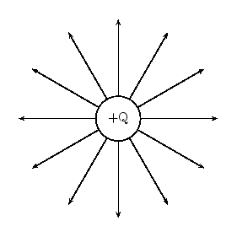

If there was a negative charge, the Electric Field lines would point inwards – towards the charge.

- The more lines per unit area (or volume) indicate a stronger Electric Field. A stronger Electric Field is also indicated by longer Electric Field lines.
- Both fields decrease in strength as 1/ r² and are described by similar mathematical equations. The Gravitational Field is much weaker than the Electric Field. The Gravitational Field always provides an attractive force, where the Electric Field provides either an attractive or repulsive force depending on the signs of the charges involved.
- The Electric Field.
- The Electric Field due to each charge is calculated independently, and then they are vectorially added to find the total field at the point.
- The Electric Potential Energy is positive. That means that it takes positive work by an external agent to overcome the repulsive force between the two like charges as they are brought together.
- The Electric Potential Energy is negative. That means that it takes negative work by an external agent to keep the charges from accelerating towards each other due to the attractive force between them.
- The equation for Electric Potential Energy is divided by a small positive test charge, q, leaving the Electric Potential dependent only on the source charge.
- The unit is the Volt. 1 Volt = 1 Joule/Coulomb. 1 Volt means that a Coulomb of charge passing through a battery would increase its energy by 1 Joule.
- An Equipotential line describes a region in space where the Electric Potential is the same. An Equipotential line is perpendicular to the tangent of the Electric Field line at all points.
- Zero work is required since Work is equal to the charge magnitude times the change in Electric Potential which is equal to zero.
- No. Or else the point of intersection would have two different values of V – which is impossible.
- The Electric Field is uniform – which means it is constant in magnitude and in the same direction at all points within the plates. Outside the plates the Electric Field is zero.
Chapter Problems

- 1.25 x 10³ N/C
- 3.15 N
- 1.3 x 10³ N/C
- 1.1 x 10³ N/C toward the negative charge
- 1.0 x 10⁻⁶ C
- 4.8 x 10³ N/C away from the positive charge
- 2.3 x 10⁻⁶ C
- F_{G} = 1.29 x 10⁻³⁴ N
F_{E} = 1.60 x 10² N; F_{E} >> F_{G}
- F_{G} = 3.21 x 10⁻⁴⁸ N
F_{E} = 1.34 x 10⁻⁵ N; F_{E} >> F_{G}
- 5.58 x 10⁻¹¹ N/C
- F_{G} = 1.03 x 10⁻³⁵ N
F_{E} = 1.28 x 10¹ N; F_{E} >> F_{G}
- F_{G} = 6.20 x 10⁻⁴⁹ N
F_{E} = 2.58 x 10⁻⁶ N; F_{E} >> F_{G}
- 1.58 N/C

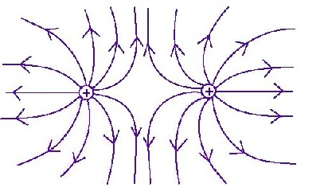

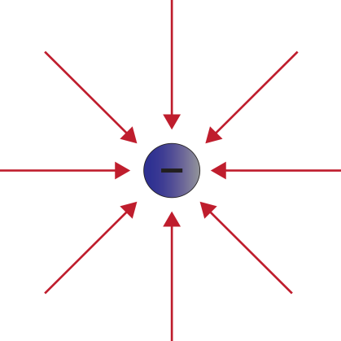

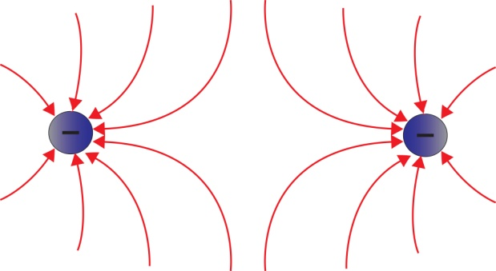

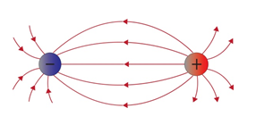

- a. 2.6 x 10³ N/C to the right
b. 7.9 x 10² N/C to the left
c. 1.8 x 10³ N/C to the right

- a. 1.7 x 10⁴ N/C to the right
b. 9.7 x 10³ N/C to the right
c. 2.3 x 10² N/C to the left
d. 2.7 x 10⁴ N/C to the right
- a. 8.1 x 10³ N/C to the left
b. 7.0 x 10² N/C to the left
c. 8.8 x 10³ N/C to the left
- a. 1.2 x 10⁴ N/C to the right
b. 5.5 x 10³ N/C to the right
c. 4.6 x 10² N/C to the right
d. 1.8 x 10⁴ N/C to the right
- -4.4 x 10⁻¹⁸ J
- 4.6 x 10⁻¹ J
- -2.2 x 10⁻¹ J
- -1.5 x 10¹ J
- 7.7 x 10⁻¹ J
- -3.1 x 10⁻¹ J
- 6.6 x 10⁻¹⁸ J
- 5.2 x 10⁻¹ J

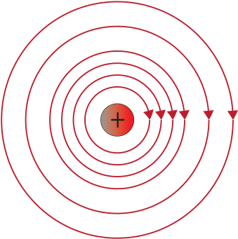

- -1.3 x 10⁵ V
- 1.8 x 10⁵ V
- 5.3 x 10⁴ V
- KE = 5.6 x 10⁻¹⁷ J; v = 2.6 x 10⁵ m/s
- -2.1 x 10⁻⁴ J
- 5.9 x 10³ V
- 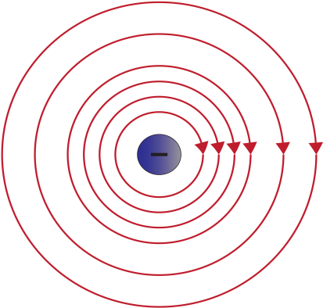
- -1.1 x 10⁵ V
- 2.0 x 10⁵ V
- -1.9 x 10⁴ V
- KE = 3.2 x 10⁻¹⁷ J; v = 8.4 x 10⁶ m/s
- 3.4 x 10³ V
- -3.4 x 10⁻⁴ J
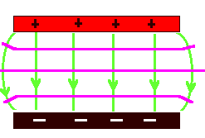
- 18 V
47.

The horizontal lines
are the Equipotentials.
48. 2.0 V
49. 4 x 10⁻¹⁶ N
50. 5.3 x 10⁻⁵ m
51. KE = 2.9 x 10⁻¹⁷ J; v = 1.9 x 10⁵ m/s
52. 1.5 x 10⁻⁴ J
53. 7.3 x 10⁻¹⁷ J
54. F_{E} = 6.7 x 10⁻¹⁶ N to East; a = 7.4 x 10¹⁴ m/s²
55.

The horizontal lines
are the Equipotentials.

56. 4.8 x 10⁴ V/m
57. 18 V
58. 2.4 x 10⁻⁵ V
59. 1.4 x 10⁻³ N/C towards the East
60. -2.0 x 10⁻¹⁷ J
61. 4.8 x 10⁴ V/m
62. KE = 1.5 x 10⁻¹⁷ J; v = 5.8 x 10⁶ m/s

General Problems

  - 610 N/C
  - 18 V
  - The drop will accelerate upward

  - 6.40x10⁻¹⁶ N
  - 7.03x10¹⁴ m/s²
  - 3.51x10⁶ m/s
  - 3.16x10⁻³ m
  - 3.75x10⁷ m/s

  - 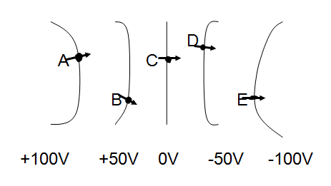
  - Between A and E
  - Between A and E
  - W_{BC} = -1.75x10⁻³ J
  - W_{ED} = 1.75x10⁻³ J
  - W_{AB} < W_{EB} < W_{AE}

  - 1.57 x 10⁻² N, F₁₂ to the left, F₂₁ to the right
  - 2.59 x 10³ N/C to the right
  - 9.50 x 10² N/C to the right
  - 3.54 x 10³ N/C to the right
  - 1.04 x 10⁴ V
  - -5.70 x 10³ V
  - 4.70 x 10³ V
  - 4.70 x 10⁻³ J

  - 4.0 x 10⁻¹⁶ N
  - 2.4 x 10¹¹ m/s²
  - 720 m/s
  - 5.9 m
  - 6.2 x 10⁵ m

  - 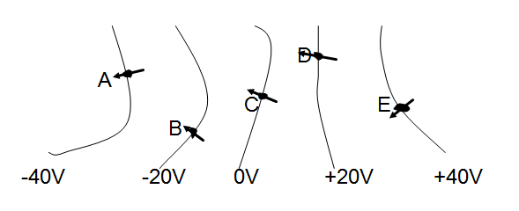
  - Between A and E
  - Between A and E
  - W_{AD} = -2.1 x 10⁻³ J
  - W_{CA} = 1.4 x 10⁻³ J
  - W_{AB} < W_{EB} < W_{AE}

  - 1.03x10⁻² N, F₁₂ to the left, F₂₁ to the right
  - 1.22 x 10⁴ N/C to the left
  - 4.28 x 10³ N/C to the left
  - 1.64 x 10⁴ N/C to the left
  - -2.43 x 10⁴ V
  - 1.71 x 10⁴ V
  - -7.20 x 10³ V
  - -7.20 x 10⁻⁵ J

  - 1.60 x 10⁻¹⁵ J
  - 6.94 x 10⁵ m/s
  - 5.00 x 10⁴ N/C
  - 2.41 x 10¹² m/s²
  - 2.88 x 10⁻⁷ s

