Electric Field, Potential Energy and Voltage
Multiple Choice Questions
PSI Physics Name____________________________________

- Which of the following represents the electric field map due to a single positive charge?
A) B) C)
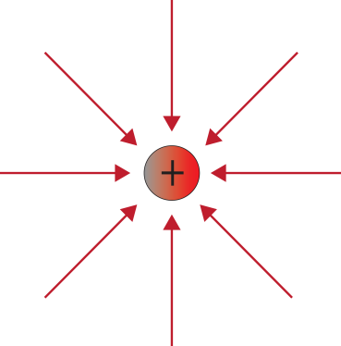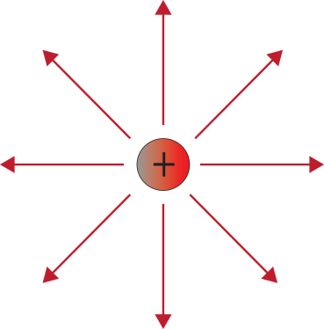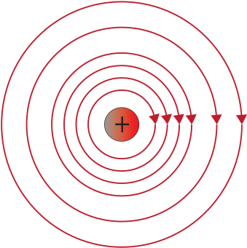

D) 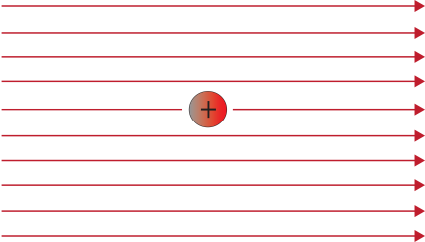 E)

- Which of the following represents the electric field map due to a single negative charge?
A) B) C)
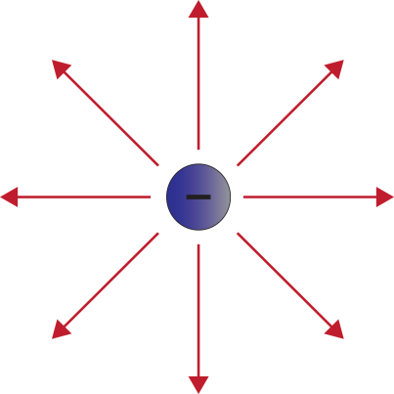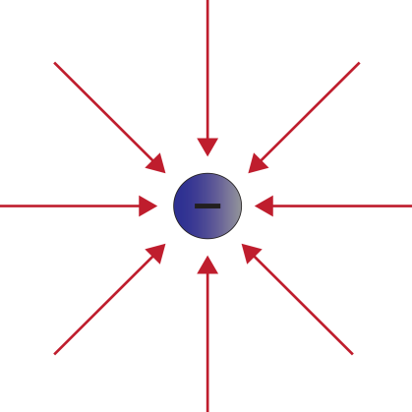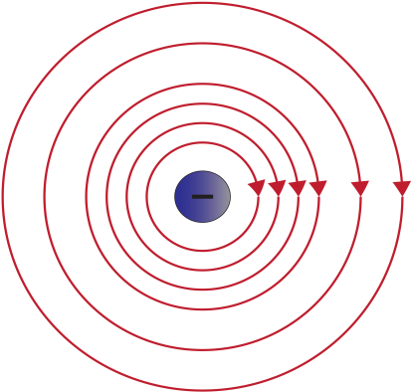

D) E)

- Which of the following represents the electric field map due to a combination of two positive charges?

A)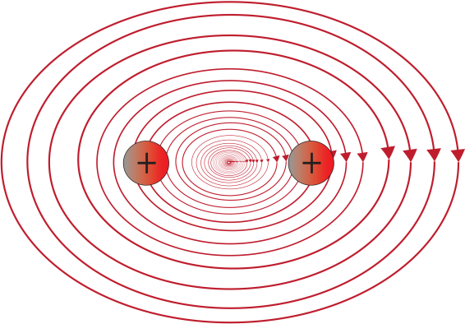 B) 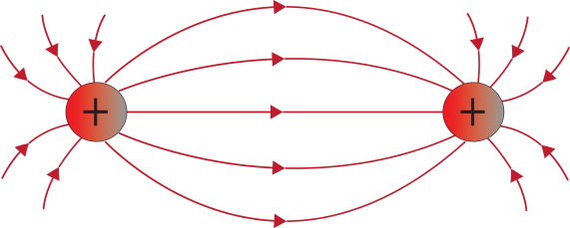

C) D)

E)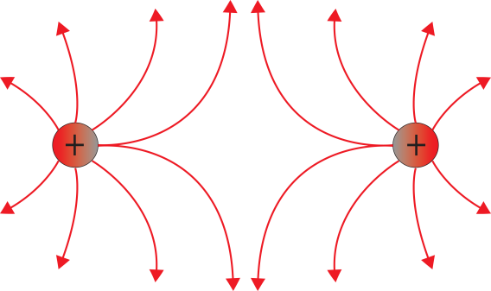

- Which of the following represents the electric field map due to a combination of two negative charges?

A)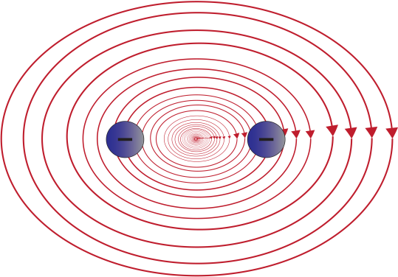 B)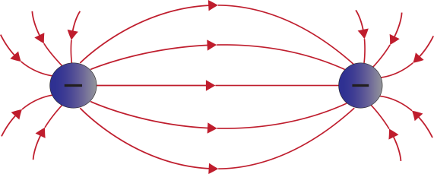

C) 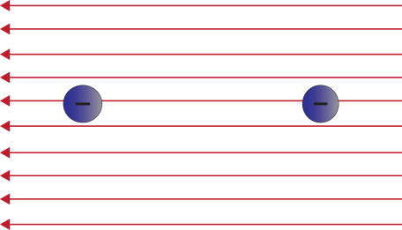 D) 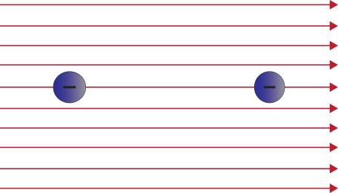
E) 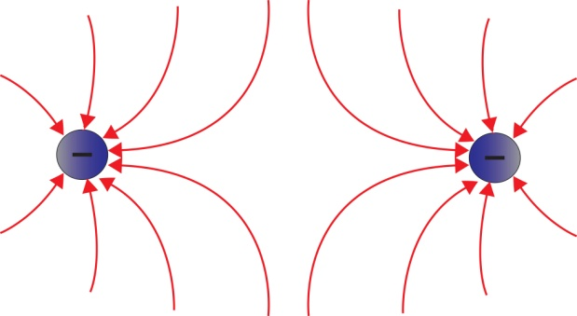

- Which of the following represents the electric field map due to a combination of one positive and one negative charge?

A)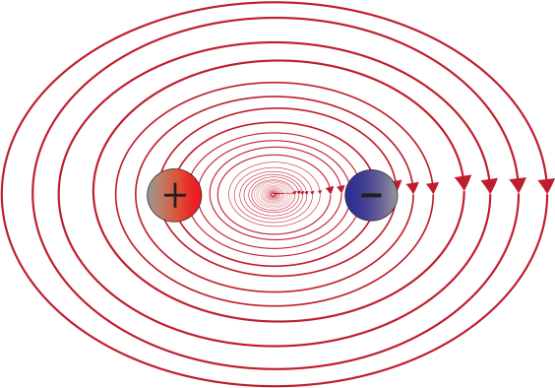 B) 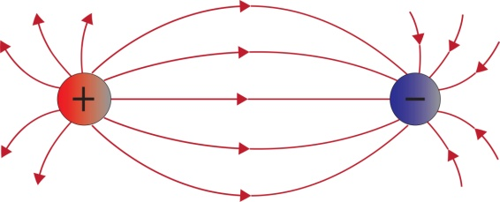

C) 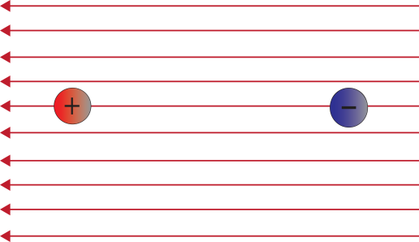 D) 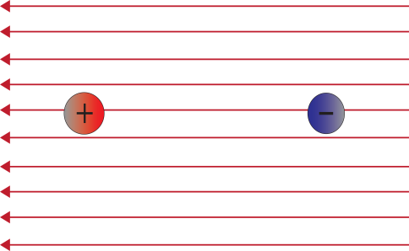

E)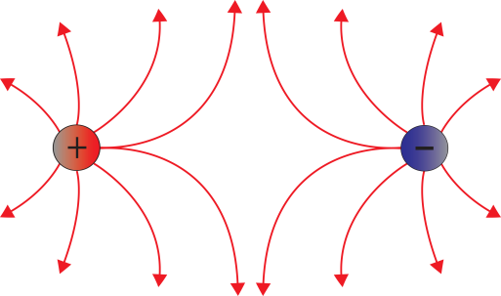

- Compare the Gravitational Field and the Electric Field produced by a proton.
  - The Gravitational Field is the same strength as the Electric Field.
  - The Electric Field is stronger and is in the same direction as the Gravitational Field.
  - The Electric Field is stronger and in the opposite direction of the Gravitational Field.
  - The Gravitational Field is stronger and is in the same direction as the Electric Field.

- Which of the following is a uniform electric field?

A. B. 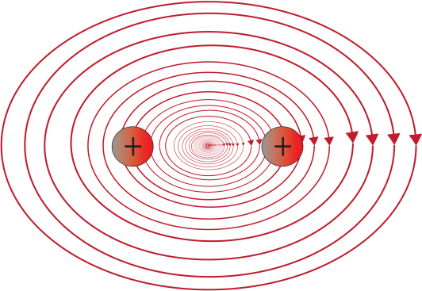

C. D.

E.
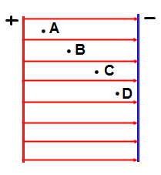
- An electric field is created by two parallel plates. At which of the following points is the electric field the strongest?
A. A B. B C.C D.D
E. The electric field is the same at all points

- An electric field is created by two parallel plates. Which of the following points corresponds to the higher electric potential?
A. A B. B C.C D.D
E. The electric potential is the same at all points

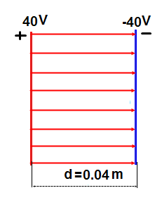
- A uniform electric field is created by two parallel plates separated by a distance of 0.04 m. What is the magnitude of the electric field established between the plates?
A. 20 V/m
B. 200 V/m
C. 2,000 V/m
D. 20,000 V/m
E. 0 V/m

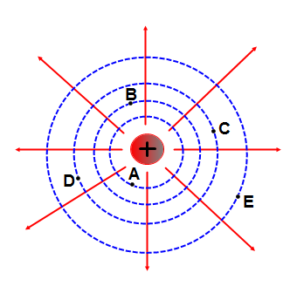
- An electric field due to a positive charge is represented by the diagram. Which of the following points has higher potential?
A. A
B. B
C. C
D. D
E. E

- An electric field due to a positive charge is represented by the diagram. At which of the following points is the electric field strongest in magnitude?
A. A
B. B
C. C
D. D
E. E

- An electric field due to a positive charge is represented by the diagram. Between which of the following two points does the electric field do zero work on a moving charge?
A. A and B
B. B and C
C. C and D
D. D and E
E. E and A

- In the above diagram, the electric potential at point A is V. What is the electric potential at point B in terms of V?
A. 2 V B. 4 V C. V D. $\frac{1}{2}$ V E. $\frac{1}{4}$ V

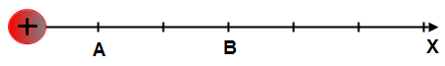

- In the above diagram, the magnitude of the electric field at point A is E. What is the electric field at point B in terms of E?
A. 3 E B. 9 E C. E D. $\frac{1}{9}$ E E. $\frac{1}{3}$ E

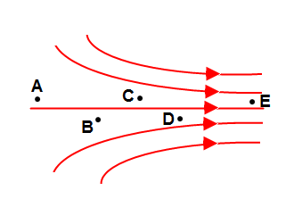
- A non-uniform electric field is represented by the diagram. At which of the following points is the electric field greatest in magnitude?
A. A B. B C.C D.D E.E

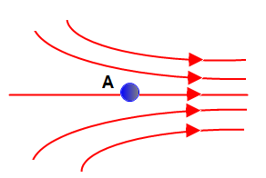
- A small conducting sphere is placed in a region of a non-uniform electric field. What is the direction of the electric force on the sphere applied by the field?
A. B. C.

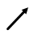

D. E.

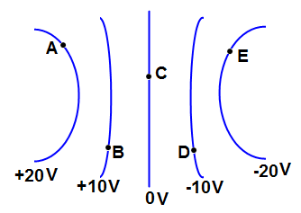
- A non-uniform electric field is represented by equipotential lines. What is the direction of the electric field at point A?
A. B. C.

D. E.

- A non-uniform electric field is represented by equipotential lines. How much work is done by the electric field when a positive charge of magnitude 1 µC moves from point A to point E?
A. 0 µJ B. 20 µJ C. 40 µJ D. 60 µJ E. 80 µJ

- A non-uniform electric field is represented by equipotential lines. A positive charge with a magnitude of 1 µC moves in the following path: A→B→C→D→E→A. How much work is done by the electric field?
A. 0 µJ B. 20 µJ C. 40 µJ D. 60 µJ E. 80 µJ

Answers
1. B
2. B
3. E
4. E
5. B
6. C
7. E
8. E
9. A
10. C
11. A
12. A
13. C
14. E
15. D
16. E
17. A
18. E
19. C
20. A

